Plasma DonorApplication Team ID: PNT2022TMID04418
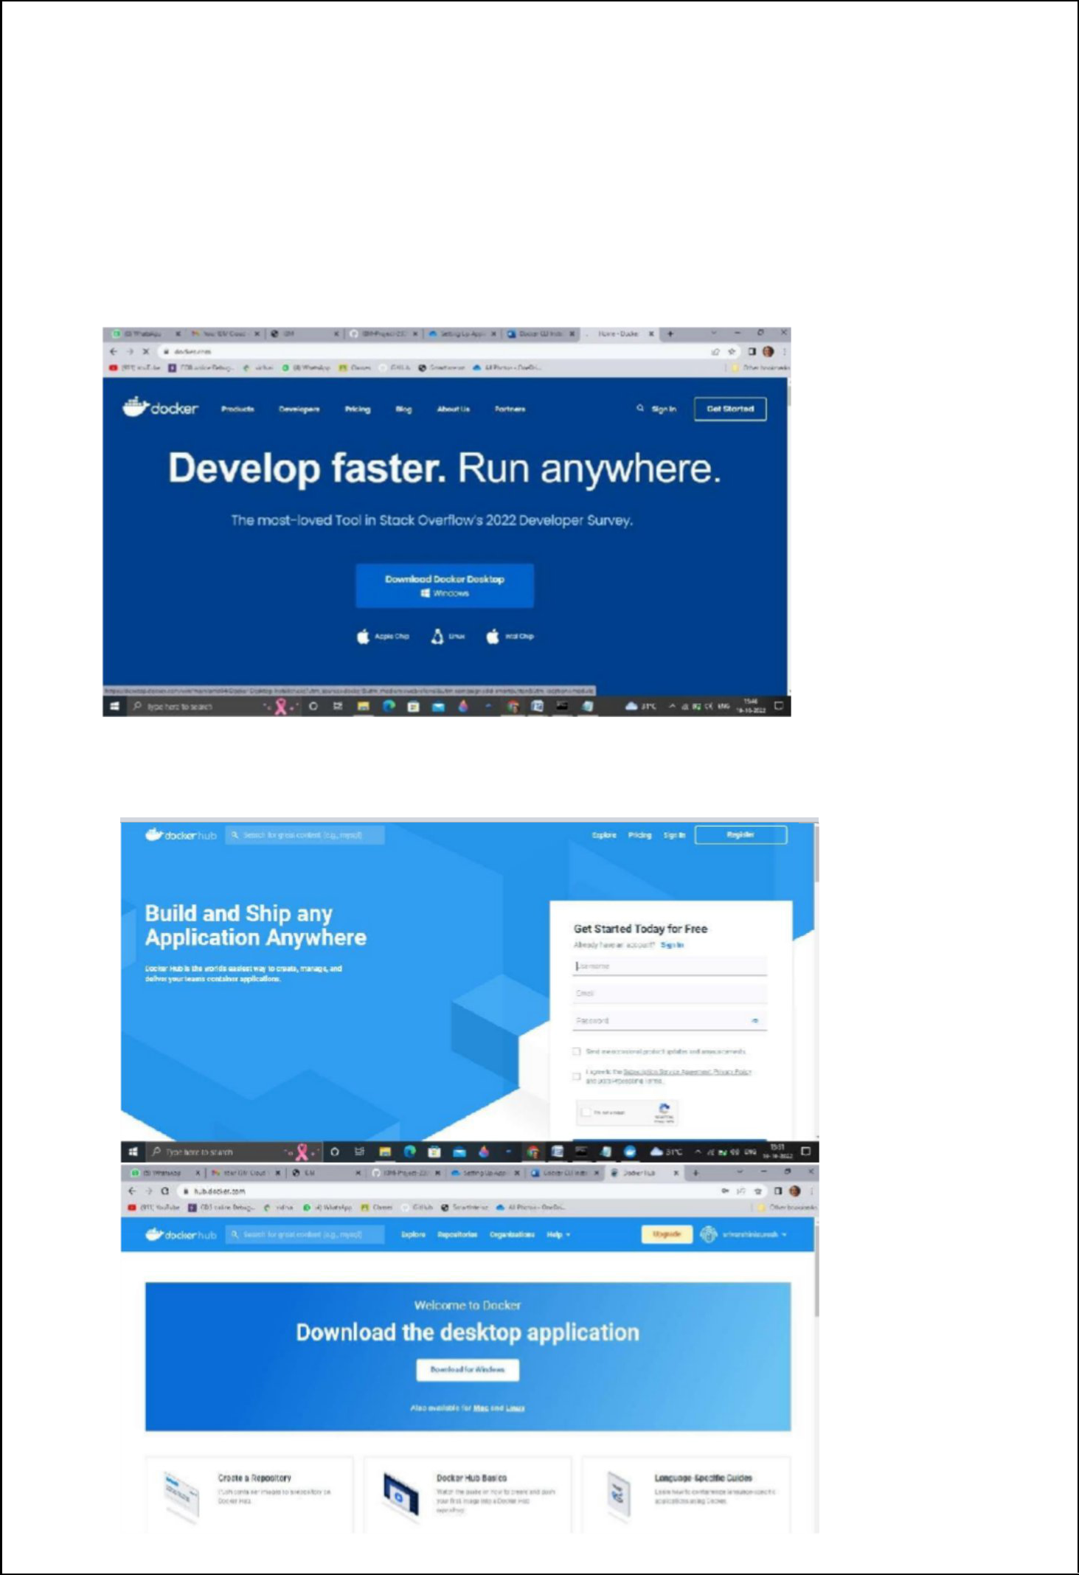

Setting up Application Environment

Docker CLI Installation

Step 1. Download Docker from docker.com and install it by running the Docker Desktop Installer.exe file.

Step 2. Goto hub.docker.com register and create an account and login with the same
Plasma DonorApplication Team ID: PNT2022TMID04418
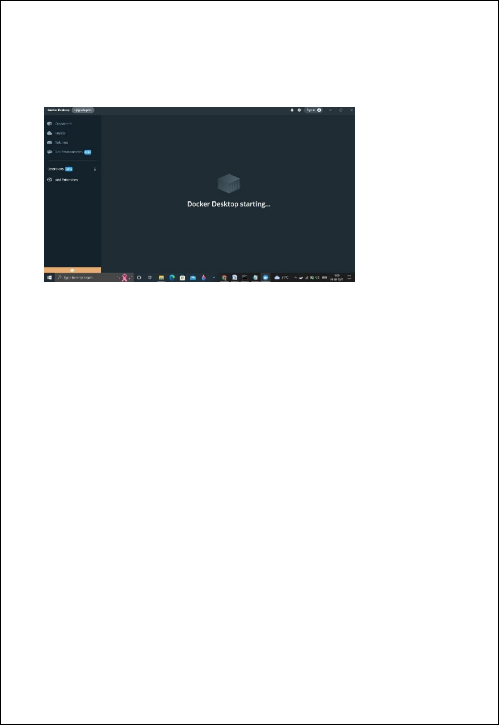

Step 3. Open Docker Desktop and start creating containers and images

